**Program 6: Write a JavaScript program that will create an array and perform following operations :**

1. **To remove specific element from the array**

// program to remove item from an array

function removeItemFromArray(array, n) {

const newArray = [];

for ( let i = 0; i < array.length; i++) {

if(array[i] !== n) {

newArray.push(array[i]);

}

}

return newArray;

}

const result = removeItemFromArray([1, 2, 3 , 4 , 5], 2);

console.log(result);

**OUTPUT:**

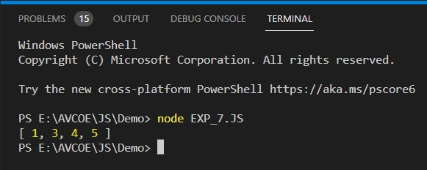

1. **Check if an array contains a specified value.**

// program to check if an array contains a specified value

const array = ['you', 'will', 'learn', 'javascript'];

const hasValue = array.includes('javascript');

// check the condition

if(hasValue) {

console.log('Array contains a value.');

} else {

console.log('Array does not contain a value.');

}

**OUTPUT:**

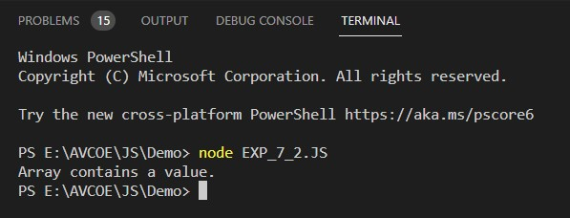

**iii. To empty an array**

// program to empty an array

function emptyArray(arr) {

// substituting new array

arr = [];

return arr;

}

const array = [1, 2 ,3];

console.log(array);

// call the function

const result = emptyArray(array);

console.log(result);

**OUTPUT:**

